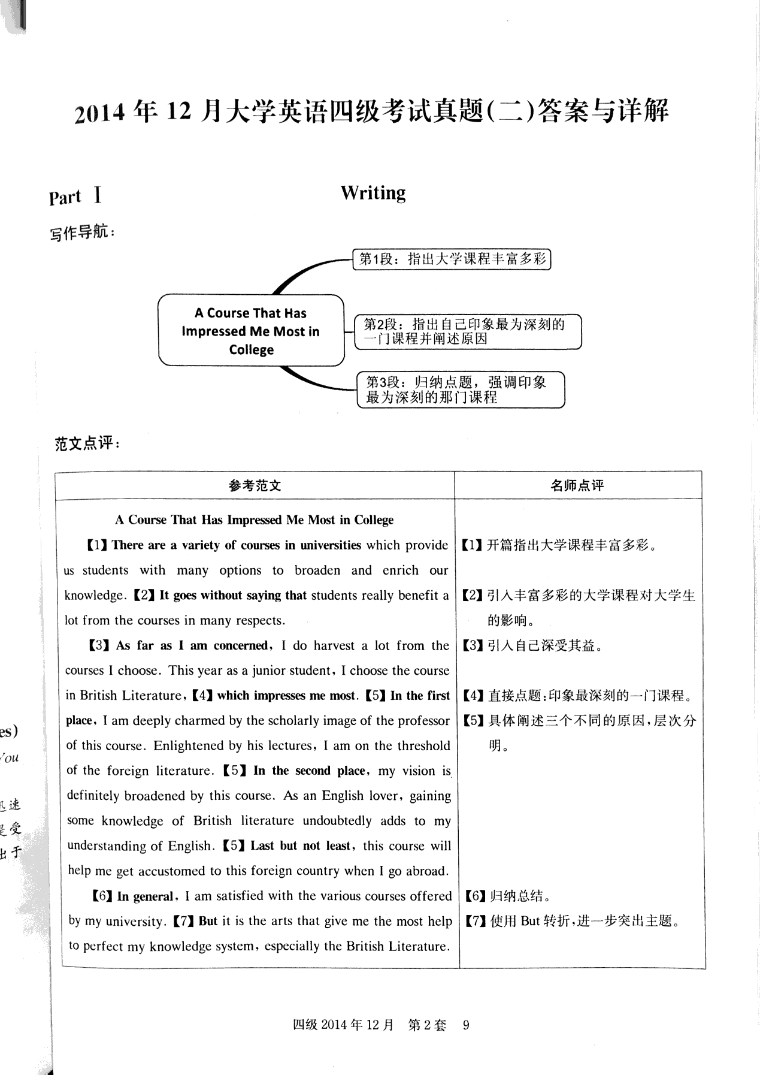

26-35 NOIKJMHLCB

36-45 FIDOKBHCLG

46-50 BCBAD

51-55 CBCAD

